**Creating a Git Portfolio**

**Project Agenda:** Creating a Git portfolio to showcase your projects.

**Description:** You are an aspiring Full Stack Java Developer and you currently undergoing a training of Java software development. In this training, there are several projects that you are creating. However, in order to organize and showcase your work to the other developers and possibility recruiters, you want to create a Git portfolio to share your projects.

**Tools/Services required:** GitHub account

**Steps to be followed:**

1. Login to your GitHub account
2. Create and upload your dummy project in a repository
3. Create portfolio repository and add the html template

**Step 1:** Login to you GitHub account

* 1. Go to the GitHub URL

https://github.com/

* 1. Provide your credentials and Sign-in

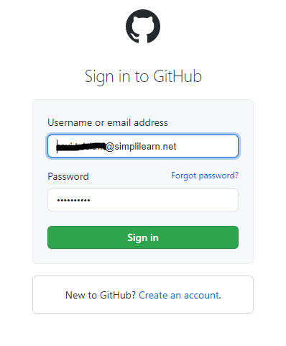

**Step 2:** Create and upload your dummy project in a repository

2.1 Create a project repository with the name **testproject** and click on **Create Repository** as shown below:

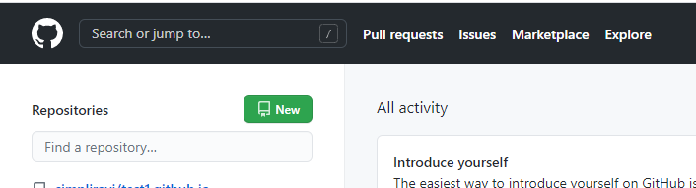

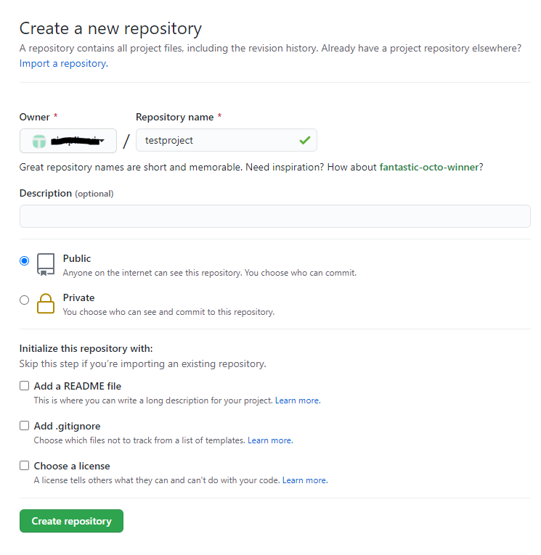

2.2 Upload a dummy project in the root folder by clicking on **uploading an existing file** as shown below:

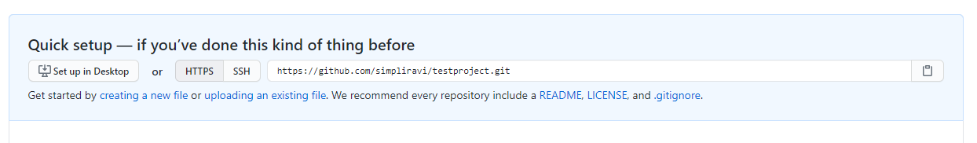

2.3 Click in **choose your files**

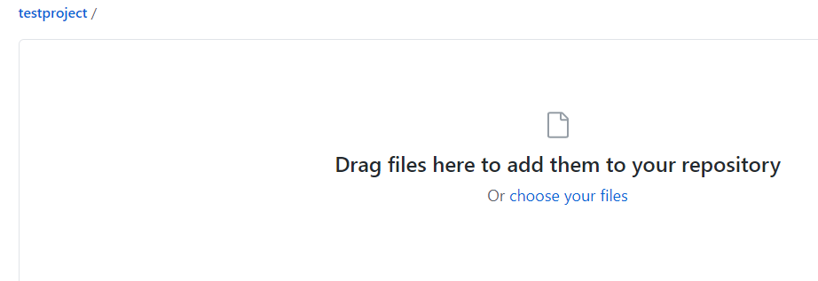

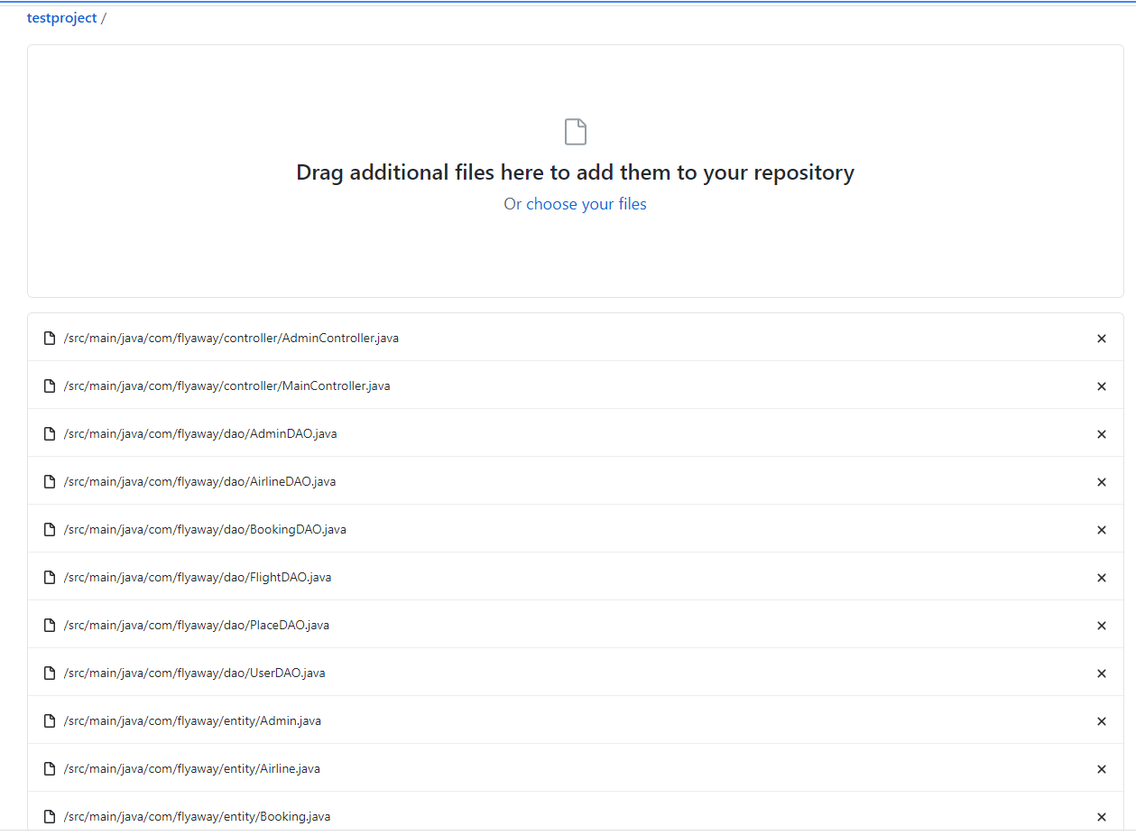

2.4 Click on **Commit changes**

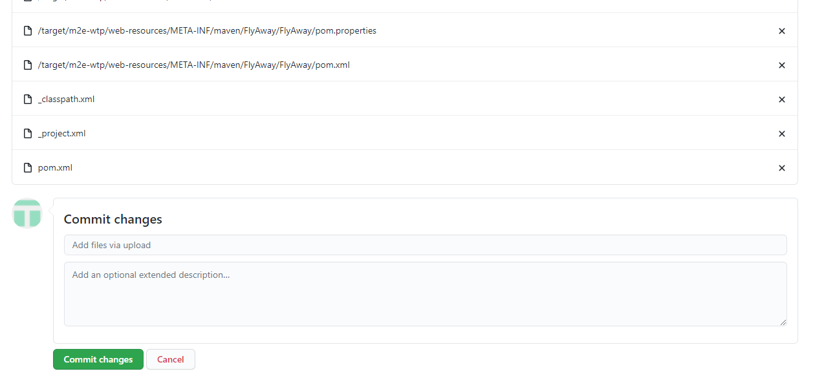

**Step 3:** Create portfolio repository and add the html template

3.1 Create a repository with the name **portfolio.github.io,** check the **Add a README file** boxand click on **Create repository**.

3.2 Download the **gitimplementation.zip** from **Course Resources** section in LMS.

3.3 Unzip and upload the **htmltemplate** folder into the **portfolio.github.io** repository as shown below:

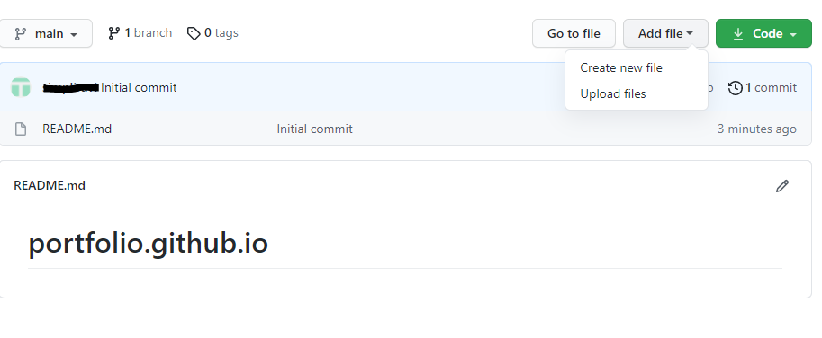

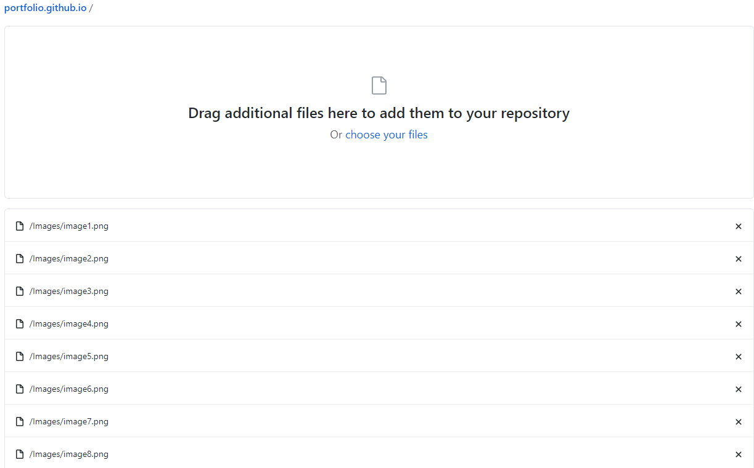

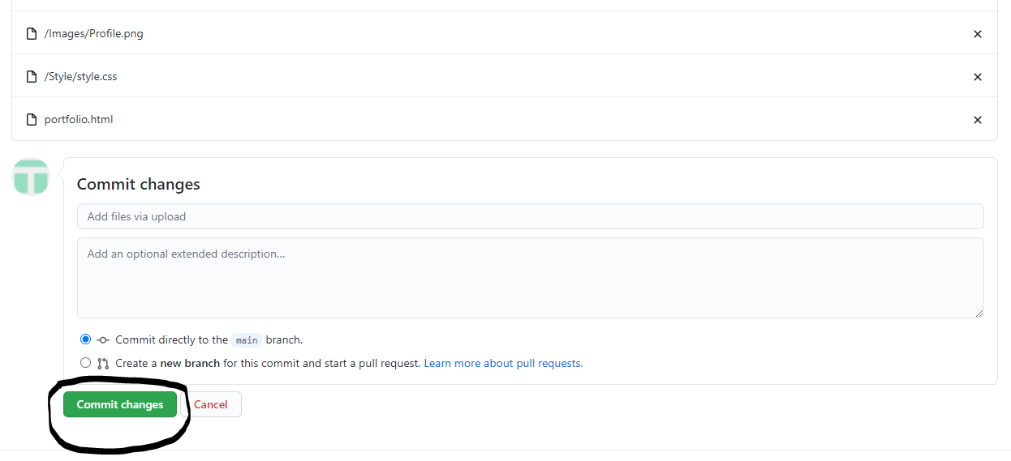

3.4Setup the url for the webpage from the repository settings as shown below:

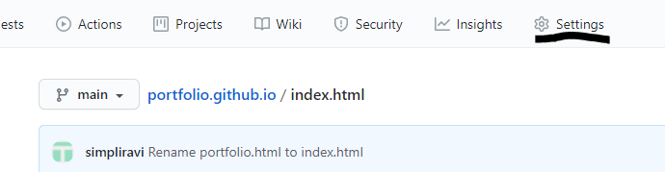

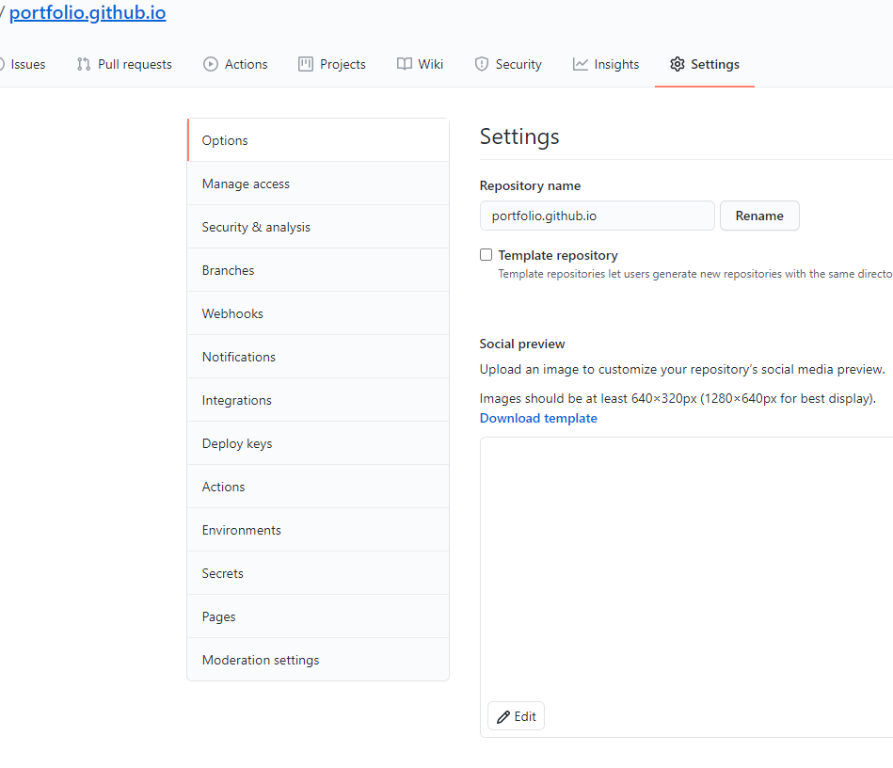

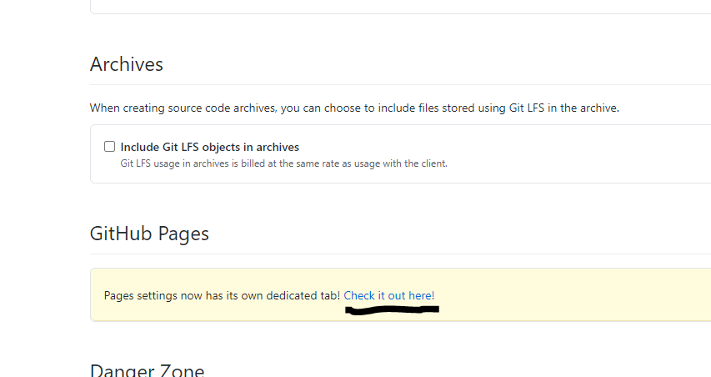

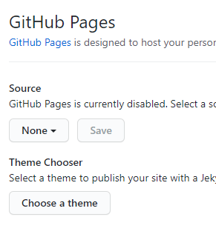

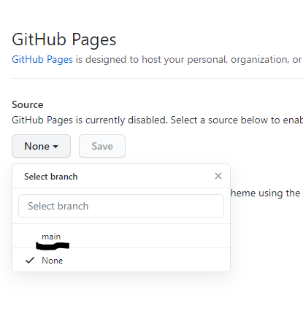

3.5 Click on **Save**

3.6 You receive a link from GitHub. Please wait for few minutes and navigate to the link to see your webpage

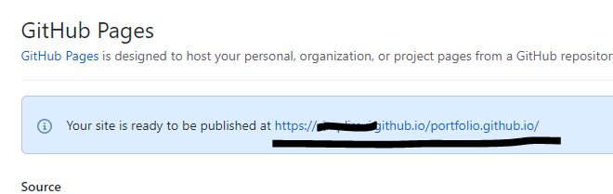

3.7 In the **index.html** file, add the link of your **testproject** repository in the project heading tags and attach your project screenshots in the **<image>** tag under your project section.